Automated Mapping of Snow Cover on Swiss Glaciers with Sentinel-2: Data Processing and Analysis

# Abstract < 1 page

Inhalt

Abstract < 1 page 1

Introduction: 2

Background and results to date 4

Goal 10

Methodology: 10

Conclusion 13

Acknowledgements 14

Reference & Literature (Bibliography) 14

Time plan: 14

# Introduction:

*Explain why this work is important giving a general introduction to the subject, list the basic knowledge needed and outline the purpose of the report.*

The rapid of the Swiss glaciers is a good indicator of climate change and warming in the Alps. To better quantify their decreasing extend and gain knowledge about their behavior in the future, mass balance models are widely applied in Glaciology.

For the Swiss glaciers, the CRAMPON project (Cryospheric Monitoring and Prediction Online) is developing an operational modeling tool to nowcast and predict mass balance and runoff to provide a near-real-time source of information on their current state and determine their behavior in the future.

For the determination of the mass balance of a glacier, i.e. the sum of how much mass a glacier is gaining, e.g. due to precipitation or losing, e.g. due to melt at any time, the amount of snow cover on the glacier and the corresponding snow line altitude (SLA) can provide valuable information.

To improve the mass balance nowcasting, the position of the corresponding transient snow line (TSL) can be used for the calibration of melt models: Therefore, the information given by the temporal variability of the TSL during the summer is employed to constrain the amount of melt by iteratively calibrating a temperature index melt model (Barandun et al., 2017).

The other use of this information in the CRAMPON project is for an online assimilation of snow-covered area to enhance the accuracy of estimated melt.

With the rapidly increasing availability of free, high-resolution satellite image data with revisiting periods within in the range of days, new possibilities to employ this data in remote sensing applications arise. In this project, we will make use of the Sentinel-2 optical data to capture the varying snow cover of the Swiss Glaciers every 5 days, depending on cloud cover in the areas. With this approach, we will be able to achieve a series with high temporal resolution as an input for the CRAMPON project.

To be able to incorporate this information in a nowcast and mass balance prediction model in a long term, an optimal mapping algorithm needs to be found and incorporated as an automated process.

However, the core question is how such an algorithm can look like. There have been numerous applications and attempts to classify snow in the optical spectrum, relying on the characteristics of the spectral response of snow in certain wavelength regions of the visible and near-infrared part of the solar spectrum.

As it can be seen in figure 1, the spectral response of ice and snow is highly varying and depends on many different parameters such as age of snow, water content, grain size, impurities, etc. and it is therefore difficult to determine the type of surface cover only by its reflectance.

In general, snow has a high reflectance in the visible (VIS) wavelengths (400 to 700nm) of over 0.9 whereas pure ice with a reflectance of around 0.6 reflects still much more than dirty glacier ice. This behavior can be explained by the fact that in the VIS range the reflectance is mostly influenced by impurities on the surface (Warren 1980).

For glacier ice the VIS reflectance in the longer infrared (IR) wavelengths (over 700 nm), the reflectance decreases significantly, while for ice the decrease is much stronger with a steeper slope. This is due to effect that the grain size affects the behavior in the middle infrared region, leading to a strong decrease for larger grain sizes (Wiscombe and Warren 1980). This characteristic of a different slope of the reflectance in the near-infrared range is often the key to distinguish between snow and ice in remote sensing data. (Dietz 2011).

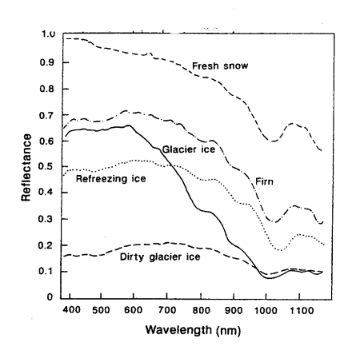

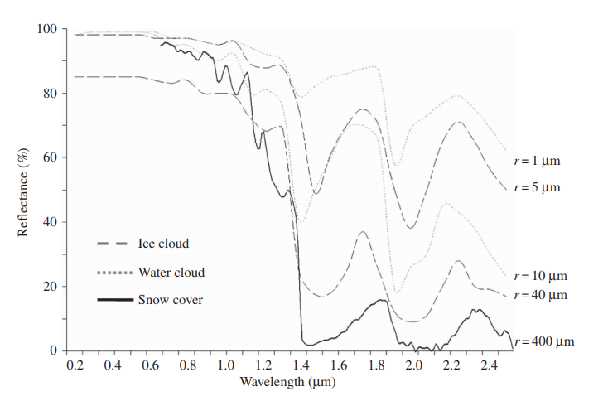

Another major challenge in snow cover mapping is to be able to discriminate between clouds and snow since they exhibit a very similar spectral behavior in the visible and thermal range. However, one characteristic that can be used to discriminate snow and clouds are the grain size of the particles, whereas water drops and ice particles in clouds have much smaller grain sizes (10 microm and 40 microm) than typical snow grains (400 microm). This leads to a stronger decrease in reflectance of snow particles in the shortwave infrared (SWIR) than for clouds and can therefore be used to detect clouds over snow (Dietz 2011). However, even though the correct detection of clouds is a difficult but crucial point to properly detect snow cover, it is not the focus of this thesis. We therefore will simply try to find the best state-of-the-art cloud cover algorithm based on previous studies that is suitable for our needs and implement it in the workflow (more on the cloud masks in Methodology).

In conclusion, the goal of this master thesis is to set up an object-oriented programming framework that finds an automated preprocessing chain of Sentinel-2 images, maps and validates the snow cover on all glaciers using a multi-spectral classification algorithm. To find an appropriate algorithm, several different approaches following state-of-the-art of snow classification will be implemented and statistically analyzed with a focus on spatio-temporal variability of snow covered area on the Swiss glaciers.

# Background and results to date

The core part of the thesis is to find a suitable mapping algorithm that can detect snow on glaciers and determine the snow-covered area as well as the snow line altitude on each swiss glacier in an automated manner. Many different approaches to detect snow have applied in the past but as a starting point, the initial focus lies on two state-of-the art algorithms: the first one presented by Rastner, 2018 (paper still under review), applying the Otsu-algorithm that finds an individual optimum threshold for each NIR band that maximizes the inter-class variance and minimizes their combined spread.

The other algorithm by Naegli, 2018 focuses on the shortwave broadband albedo in a multi-step classification scheme including the glacier geometry and altitude to retrieve the bare-ice area versus snow-covered surfaces.

## Rastner:

The ‘ASMAG’ (Automated snow mapping on glaciers) (figure 3) algorithm that Rastner developed uses 63 Landsat scenes that were processed individually to detect the snow-covered area and the SLA for each scene. For the processing, the required input consists of all Landsat satellite bands, a digital elevation model (DEM) containing all glaciers that is derived from several available DEMs and manually derived glacier outlines.

The Landsat imagery undergoes extensive pre-processing, converting radiance bands to reflectance bands. This, the sun incidence angle, the slope, aspect and a hill shade of the input DEM is located and used to apply an Ekstrand correction only to the NIR band (Ekstrand, 1996).

From the thermal band, the brightness temperature is derived and applied on bright areas to determine if they are snow(cold) or clouds(warmer). This way, a cloud mask is created that is applied individually for each scene and only scenes with less than 10% cloud cover are processed by the algorithm.

The actual thresholding of the ASMAG is then performed on the NIR band for each glacier individually using the Otsu-threshold. It assumes that the scene’s histogram is bimodal, having two peaks that correspond to ice and snow and now find the optimal threshold that maximizes the inter-class variance and minimizes their combined spread. Applying this threshold to the scene gives a direct bimodal snow cover map of the area. In order to retrieve the snow line altitude in ASMAG, the applied DEM is split into 20 m elevation bins with which the snow-cover map from the previous step is intersected. If the first (lowest) five elevation bins all have a snow cover larger than 50%, the lowest of these bins is selected as the SLA. If not, the iteration is repeated for the next higher set of five bins. If there are no five continuous bins that meet that criterion throughout the entire glacier, the same test is repeated for four, three, two or one bin to retrieve the SLA.

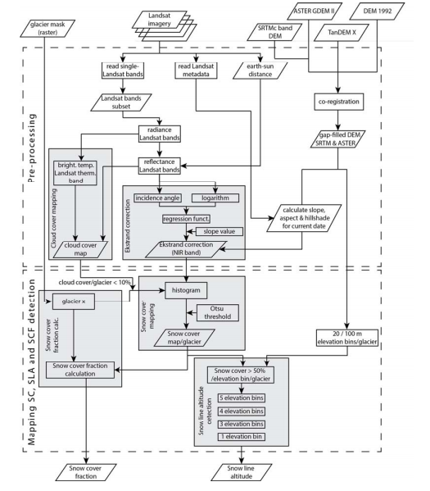

## Naegli:

In Naegli 2017, a method to retrieve the remotely determined end-of summer albedo of Swiss glacier ice is described. It uses a mulit-spectral Landsat surface reflectance product and a 30 m resolution DEM as input, pre-processing is only applied in form of a semi-automated cloud mapping approach to exclude cloud-affected pixels from the classification.

In a next step, the discrete narrow-band reflectance is converted to a continuous shortwave broadband albedo. This conversion in general requires knowledge about the spectral response of different snowpacks (Bamber), however, Naegli et al- (2017) showed that this albedo retrieval approach provides very high accuracy and is suitable for mountain glaciers and can therefore be applied for this method. From the broadband albedo, a multi-step surface type evaluation is performed to discriminate between snow covered areas and bare ice. First, a primary surface type evaluation is performed, that classifies every area with an albedo higher than 0.55 certainly as snow and below 0.25 certainly as ice, based on Cuffey and Paterson, 2010. In the critical albedo range between 0.25 and 0.55, the fact that the snow-to-ice transition is usually the part with the strongest albedo change, is used. By using the altitude where the highest slope in the Albedo occurs as an estimate for the SLA, the local albedo at this point is used as a critical value that distinguishes ice from snow. All grid cells within the ambiguous albedo range are then reclassified by the critical albedo value and corrected for extreme outliers by their relative altitude compared to the SLA. In this way, a high albedo value that is very close to the front glacier will still be classified as ice while a low albedo cell high up the glacier will be mapped as snow, thus implicitly leaving a certain range of deviations e.g. for terrain shadows that alter the albedo but will still provide a good snow cover map.

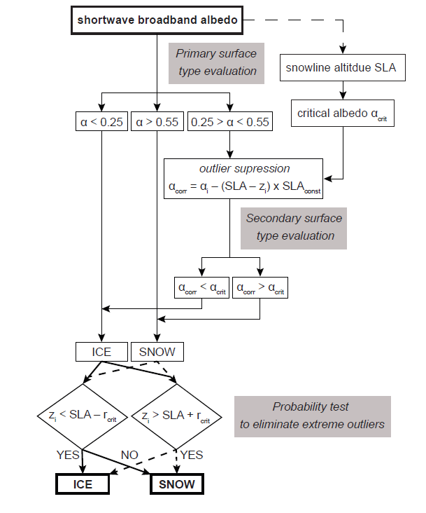

**Other approaches – Literature review**

The ASMAG algorithm that relies on detailed pre-processing and the flexible Otsu-algorithm to create a snow cover map and on the other hand the albedo-retrieval function by Naegli that uses a probabilistic penalty approach for the classification are two very different but both promising approaches that will provide the base of this master thesis. There is the question, how well each algorithm will perform and how they compare to each other. Furthermore, the question if those algorithms can be improved or any other approaches might bring even better results will be answered in this master thesis. For the specific task of automated mapping of snow on glaciers, there have not been too many different approaches in the past.

There are many algorithms to discriminate between snow and environments (see Paul et al. 2015, Paul 2016, König 2015 for a review), often using thresholding on simple bands, band ratios, differential ratios such as the NDSI or combinations of the three. Many of them have manually been applied successfully to map glacier extends (Paul 2016) and some have even been implemented into an automated workflow (e.g. snow scene classification of Sentinel-2 Level 2 A data). However, usually the contract between snow and other environments is much higher and easier to map automatically. For the mapping of snow and ice, the NDSI does not yield good results.

Others: Paul 2016: Sentinel-2 Snow cover with NIR band 🡪 Manually adapted threshold

approach with NDSI for snow on ice only🡪 Differential ratio 🡪 Khan; Paul 2016: poor results, not appropriate.

Rabatel 2012a: SLA in tropics: uses near-infrared and shortwave infrared bands with thresholds

for the green and near-infrared bands. The thresholds depend on lighting conditions on the acquisition date for each image 🡪 very clear delineation but no statistical analysis of results, only optical evaluation and comparison against field data 🡪 revaled good match (Also used by many others, Veettil 2014, 2015, Rabatel 2015 and Presentation)

Other ideas:

Seidel: manual, Snow Cover Units 🡪 mapping even with clouds?

Fractional Snow Cover (Bippus) from Sentinel 1 🡪 SAR Daten? 🡪 only wet snow 🡪 not universally applicable. Was sinnvoll für Optische Daten?

Cloud Mapping 🡪 Picking continuos area, then looking for shadows to detect corners… 🡪 any ideas how to apply for glacier?

Nothing applicable for our purposes

Challenge for automatization: Thresholding often needs to be adjusted manually: what characteristics can we extract from an image or a combination of different bands, that discriminate snow and ice in as many situations as possible? Can a decision tree be identified and implemented in an automated manner?

Suggestions: instead of using Albedo for Neagli algorithm, use single band or ratio for discriminating? Less error due to broadband-conversion and maybe better snow-ice contrast than in albedo? Need to study for appropriate tresholds then

Rastner: Use other ratio instead of only NIR band, then apply Otsu 🡪 maybe better contrast? E.g. same as Rabatel 2012? Test different combinations here

**Results to date:**

To get familiar with the Sentinel-2 imagery and potential ways to process them using Python, a test set of level 2-A products (more details on the sentinel-2 Data type in Methodology) was manually downloaded to perform some basic preprocessing and some tests.

First, the scene of the central Swiss Alps that contains many of the bigger Swiss glaciers, was intersected with the glacier mask from the Swiss Glacier Inventory SGI from the year 2010 (a newer version from 2018 is available in theory, however, there were problems with the data format, so the older version was used for this test). In a next step, a suitable cloud detection algorithm had to be found (more in methodology), in the end the cloud mask that is included in the Sentinel-2 Level 2A products was used for this test to detect and exclude cloud-covered areas.

On those pre-processed images, two tests were performed: Firstly, the Otsu-thresholding as used in the ASMAG algorithm was applied to an extract of the Fiescher Glacier of the NIR band (Band 08) to produce a first guess of a snow cover map (figure 3.2). However, the Sentinel-2 data are not yet terrain corrected since no DEMs have been employed so far, so the results especially in steeper parts of the glaciers might not be ideal yet. Secondly, a the narrow-to-broadband conversion as suggested by Naegli 2017 based on Knap et al. was performed on band 08 and band 03

*a*Knap = 0.726b3 - 0.322b2^3 -0.015b8 + 0.581b8^2

On this shortwave albedo, the thresholds that discriminate between certainly ice (<0.25) and certainly snow (>0.55) are applied to create a map that represents the snow cover and the area on which the secondary surface type evaluation, shown in grey in figure 4.3. as described above, will be performed. Those results, as applied on a scene of the NIR band of the Rhone glacier are displayed in figure 4.

The scene is from October 17th reveals a rather “patchy” snow cover and contains fresh snow as well as firn while the tongue of the glacier still seems to be bare ice. This feature of the patchy snow cover is a major challenge in the proper classification of snow on glaciers, even with the bare eye it is often impossible to give a good estimate of the snow line since it is more of a gradual transition zone than a sharp line. It might be a useful idea to retrieve a probability distribution of the SCA and SLA instead of creating a binary map in order to give a more realistic representation of the snow cover. This is going to be explored further once the main algorithms will be implemented, depending on their performance.

However, several characteristics can be noted by visually inspecting the results:

Firstly, the applied cloud mask seems to heavily overestimate the cloud cover/ misclassify snow as clouds over large parts of the glacier. This area also has a very light cirrus cover, but since the Level 2-A products are cirrus-corrected, this should not be a problem for the cloud cover map. It is more likely, that the Sen2Cor cloud mask simply is not performing very well in glacial areas and might therefore not be the ideal choice for the automated implementation. Hence, other algorithms must be investigated in the thesis to find the best performing one.

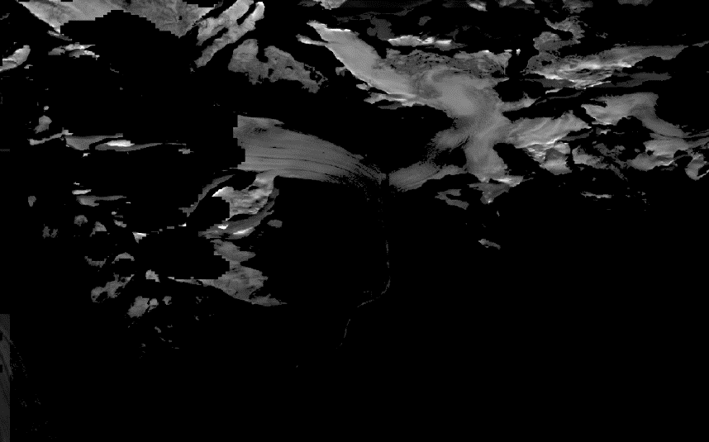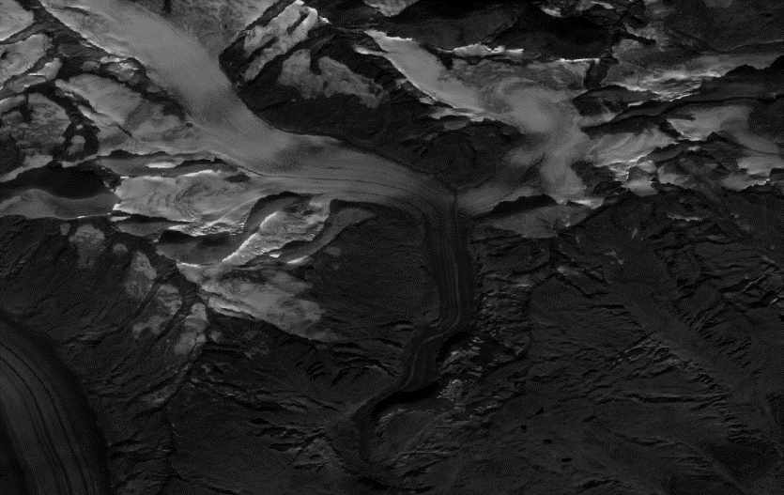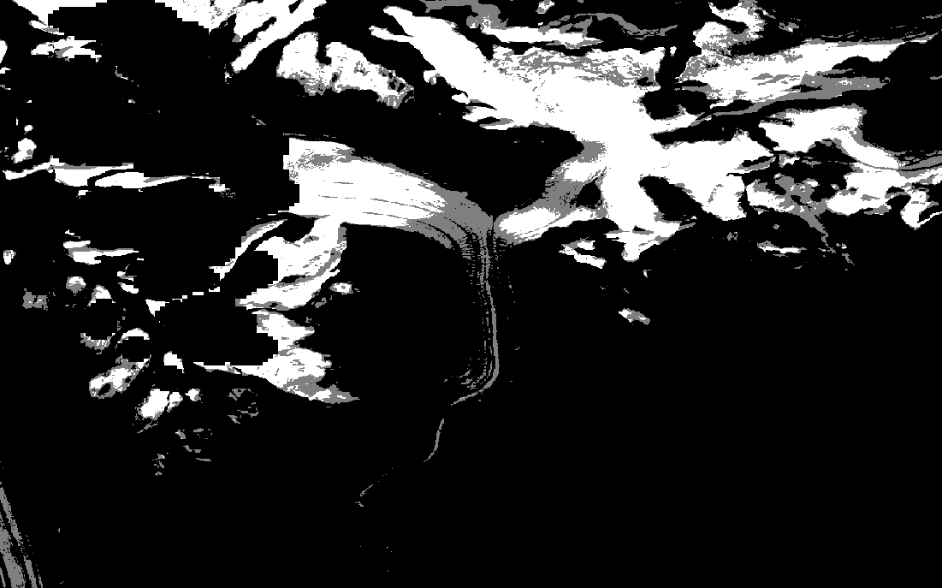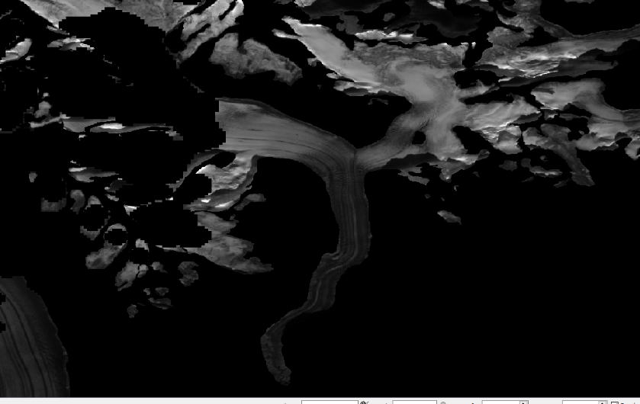

Secondly, the applied Otsu- algorithm performs a very good first-guess snow cover map for this scene, finding a good fit for the snow line on the tongue and a continuous snow cover on the higher parts. The histogram also shows the bimodal characteristic of this scene very well, with two clear peaks for snow and ice and an Otsu-threshold of 0.33. Only a part of the very small line of very clear ice in the tongue seems to be misinterpreted as snow.

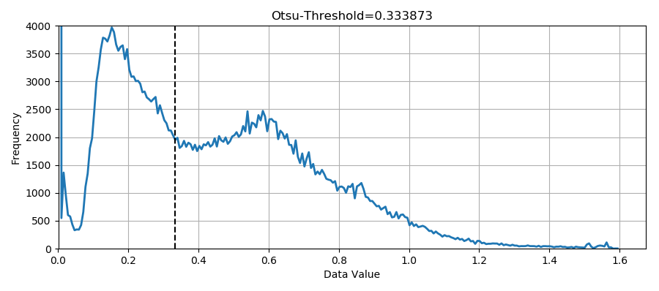

The albedo approach after Naegli, 2017 generally classifies a smaller area than the Otsu-algorithm as certainly snow, which is what would be expected. Since most of the ambiguous range (grey) is in the higher area of the glacier, the penalty function approach would most likely result in a correct classification of them as snow. Only for the snow line, the ambiguous range is quite high and without employing a DEM, no estimation of the snow line altitude can be given.

Goal:

*List the main research question(s) you want to answer. Explain whether your research will provide a definitive answer or simply contribute towards an answer.*

With this knowledge, the goal of this master thesis will be to implement the workflow into an automated object-oriented programming framework in python that

1. Downloads and pre-processes the Sentinel-2 images based on cloud cover, terrain corrections, etc. for all Swiss Glaciers
2. Retrieves a snow cover map and the snow line altitude by applying the algorithms presented by Rastner and Naegli and possibly other suitable algorithms

In a next step, the results should be validated against some manually classified scenes via a statistical analysis to give an answer to the question, which of the given algorithms provides the best results for high resolution snow cover mapping in an automated manner.

Furthermore, an analysis focusing on the spatio-temporal variability of the snow cover and snow line altitude will be performed, revealing trends in the cover of the Swiss alps as well as potential weaknesses/strengths of each algorithm. A special focus will lie on the determination of uncertainties in each part of the processing workflow.

# Methodology:

*Explain the methods and techniques which will be used for your project depending on the subject: field work, laboratory work, modeling technique, interdisciplinary collaboration, data type, data acquisition, infrastructure, software, etc.*

**Sentinel-2 Data:**

Sentinel- 2 is an ESA mission highly complementary to the USGS Landsat 7 and 8 data that has often been used in many scientific remote sensing applications. It consists of two satellites, Sentinel-2A and 2B that were launched in 2017. Together they have a revisiting time of 5 days at the equator with 13 different multispectral imaging (MSI) sensors ranging from Visible and Near-Infrared to shortwave infrared with a resolution of 10m to 60 m (see Figure xxx for an overview of the bandwidths of the Sentinel-2 bands)

https://esamultimedia.esa.int/docs/EarthObservation/Sentinel-2_ESA_Bulletin161.pdf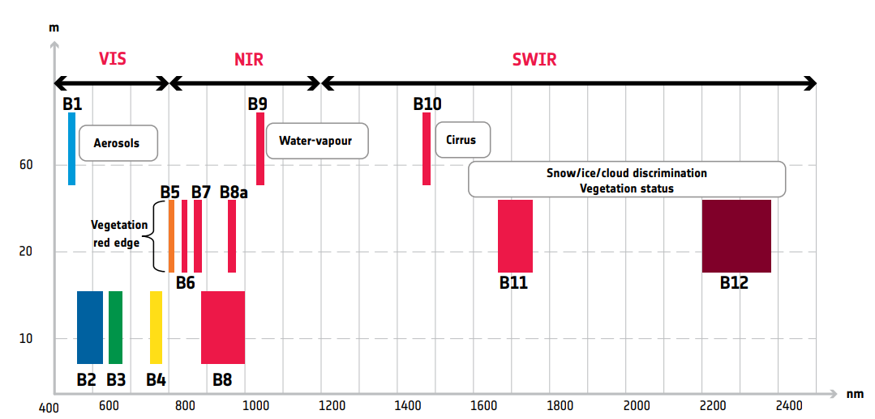

Spatial resolution versus wavelength of Sentinel-2 13 spectral bands. Source: https://esamultimedia.esa.int/docs/EarthObservation/Sentinel-2_ESA_Bulletin161.pdf

**Data retrieval/Download**

All Sentinel-2 Data products can be accessed for free in the Copernicus Open Access Hub with a user account. Users need to sign up for an account and can then sort the tiles by satellite, region, acquisition date, snow cover, processing format, etc. and then download the data in the .SAFE format as specified by ESA’s guidelines. Each data tile of 100km^2 x 100km^2 size in Level 2A has an approximate file size 0f 800 Mb. Command line options to access the Sentinel-2 data directly via the hub are also accessible.

However, since this thesis aims to develop an automated processing framework that includes data retrieval and will be programmed in python, the way of interest to download the data will be via the ‘sentinelhub’ package by singergise. It allows for automated downloading of any combinations of bands into GEOtiff, significantly minimizing the amount of data storage since only the needed bands and metadata will be downloaded. This service is linked to the Copernicus Hub and therefore requires a user ID that is linked to this account. However, for continued access to the data, a request including a proposal for the project and its scientific purpose has to be submitted and accepted by the OGC EO Interface Integration Service.

Another option using the sentinelhub package is to access the data from AWS S3 storage buckets, which charges for the requested data amount, around 0.09 per GB of data. This way, the data can also be stored

**Processing Levels and Data formats**

The Sentinel-2 Data is usually delivered in the SENTINEL-SAFE file structure, including image data in JPEG2000 format, quality indicators (e.g. defective pixels mask), auxiliary data and metadata. A detailed description of the file structure and content of the folder can be found in ESAs Technical Guide for Sentinel-2.

The Sentinel-2 Data is currently made available via the Sentinel Hub and AWS in two processing levels: Level 1-C data that gives radiometrically and geometrically corrected Top of Atmosphere (TOA) reflectance per pixel. Then the next higher level is the Level 2-A product where the output is an orthoimage Bottom-Of-Atmosphere (BOA) corrected reflectance product. It is possible to either retrieve the Level 2-A product directly in the .SAFE format or to process the Level 1-C data manually with the Sen2Cor module. When applying the Sen2Cor manually, the option to apply cirrus correction as well as a topographic correction can be chosen (see below). Since this this project works in steep mountainous terrain, the output would greatly benefit from such a correction.

**Internal corrections: Cloud Masks**

Since the Swiss Alps are often affected by cloud cover that are opaque for optical sensors, a correct classification of clouds over the glaciers is very important. There are several different approaches on how to map cloud cover on glaciers.

For the preliminary work, simply the cloud mask delivered by with Sentinel data on a 60m grid was used. It is based on a threshold applied to the blue B2 band and then the SWIR band B11 and B12 to take advantage of the differences in the spectral response of snow and clouds as described in the introduction (for details see Technical ESA report). In the scene of the Fieschergletscher, this algorithms already revealed its weakness: In any even slightly snowy area, the algorithm seems to fail and misclassify large areas as

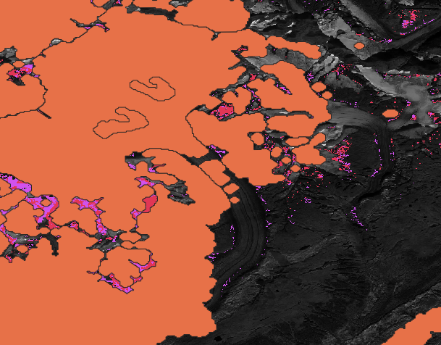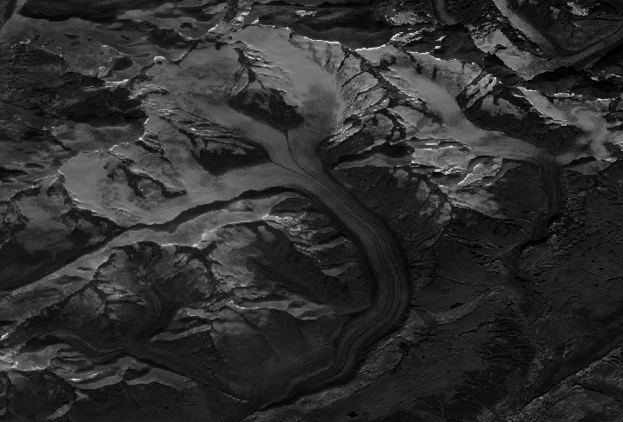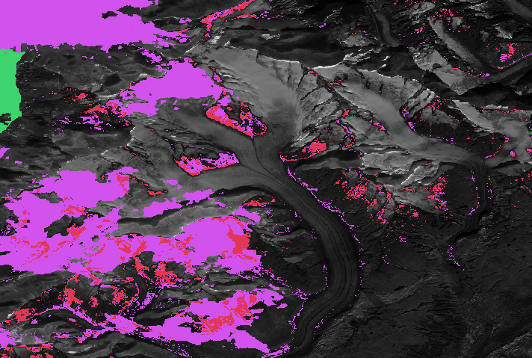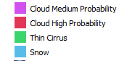

clouds (Figure xxx for an example scene of Aletsch Glacier). Coluzzi, 2018 found similar problems in their study, suggesting to use this cloud mask with precaution especially in Alpine environments.

Another approach that was investigated is to use the scene classification that gets provided with the Level-2A products and extract a manual cloud mask from the scenes that got classified as either “Cloud Medium Probability”, “Cloud High Probability” or “Thin Cirrus”. From a visual inspection, the results are a lot more better and detailed, especially since they are provided with a 10 m resolution, so for a fast test, this would be the required approach. However, while the actual cloud mask highly overestimated the cloud cover, many smaller, lower clouds on the higher parts of the glacier did not get classified correctly.

Since those results are not satisfying, other options have to be explored.

* Other Cloud masks
* Influence of clouds 🡪 goal is to achieve a contionuos time series 🡪 what do we do if several fly overs in a row are cloudy?
* Cloud probability: what extend of clouds can still provide a ´good classification? (Clouds on glacier)

Topographic correction? Important in mountain areas with steep slopes, creating s

* Sen2cor (apparently topographic correction does not work yet?)….. Level- 2A products (needed for Nageli)? --> manual correction with Sen2Cor? Those have only atmospheric but no terrain correction
* Sen2cor do terrain correction using Level 1C input
* Use DEM with only 90m resolution input
* Paul 2016: Comment about how terrain correction needs better orthorectification

External needs:

* Glacier Masks: SGI 2010 🡪 find 2018
* **DEM: Swiss Alti 3D**

# Discussion / Conclusion

*Explain what is striking/noteworthy about the results. Summarize the state of knowledge and understanding after the completion of your work. Discuss the results and interpretation considering the validity and accuracy of the data, methods and theories as well as any connections to other people’s work. Explain where your research methodology could fail and what a negative result implies for your research question.*

# Acknowledgements

*Thank the people who have helped to successfully complete your project, like project partners, tutors, etc*.

# Reference & Literature (Bibliography)

*List papers and publication you have already cited in your proposal or which you have collected for further reading. The style of each reference follows that of international scientific journals.*

# Time plan:

*Give a detailed time plan. Show what work needs to be done and when it will be completed. Include other responsibilities or obligations.*